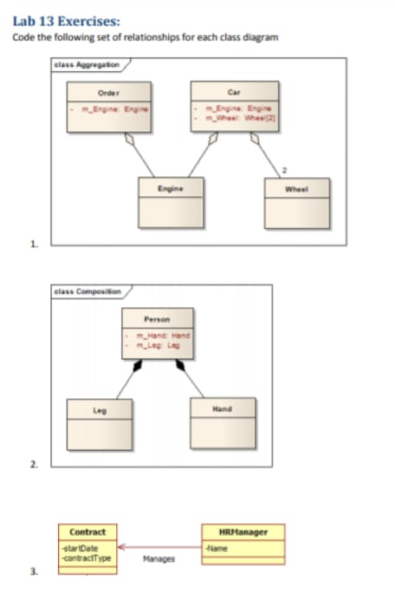

**Q1)**

CODING:

using System;

namespace OOPlab13

{

class programm

{

static void Main(string[] args)

{

engine OBJ1 = new engine("eng of anytype", "2018", 18000);

order OBJ2 = new order("confirm ", "2016", 12000, OBJ1);

wheel OBJ3 = new wheel("acceptable", 3000);

car OBJ4 = new car("CULTUS", "2017", 1900000, OBJ3, OBJ1);

OBJ4.cardetails();

OBJ2.orderdetails();

OBJ1.enginedetails();

OBJ3.wheeldetails();

Console.ReadLine();

}

class car

{

string CARNAME;

string CARMODEL;

int CARCOST;

wheel CARWHEEL;

engine CARENGINEE;

public car(string cNAME, string cMODEL, int cCOST, wheel cWHEEL, engine cENGINEE)

{

CARNAME = cNAME;

CARMODEL= cMODEL;

CARCOST = cCOST;

CARENGINEE = cENGINEE;

CARWHEEL = cWHEEL;

}

public void cardetails()

{

Console.WriteLine("The carname is" + " " + CARNAME);

Console.WriteLine("The carmodel is" + " " + CARMODEL);

Console.WriteLine("The carcost is" + " " + CARCOST);

}

}

class order

{

string orderconfirmation;

string orderdealdate;

int ordercost;

engine ENGInNE;

public order(string oCONTACT, string oDEALDATE, int oCOST, engine ENGINEE)

{

orderconfirmation = oCONTACT;

orderdealdate = oDEALDATE;

ordercost = oCOST;

ENGInNE = ENGINEE;

}

public void orderdetails()

{

Console.WriteLine("The order is " + " " + orderconfirmation);

Console.WriteLine("The order deal date is :" + " " + orderdealdate);

Console.WriteLine("The order total cost is" + " " + ordercost);

}

}

class engine

{

string enginename;

string engineexpiry;

int enginecost;

public engine(string eNAME, string eEXPIRY, int eCOST)

{

enginename = eNAME;

engineexpiry = eEXPIRY;

enginecost = eCOST;

}

public void enginedetails()

{

Console.WriteLine("The engine name is : " + " " + enginename);

Console.WriteLine("The engine expiry date is : " + " " + engineexpiry);

Console.WriteLine("The engine cost is : " + " " + enginecost);

}

}

class wheel

{

string wheelquality;

int wheelcost;

public wheel(string wQUALITY , int wCOST)

{

wheelquality = wQUALITY;

wheelcost = wCOST;

}

public void wheeldetails()

{

Console.WriteLine(" The wheel quality is : " + " " + wheelquality);

Console.WriteLine("The wheel cost is : " + " " + wheelcost);

}

}

}

}

OUTPUT:

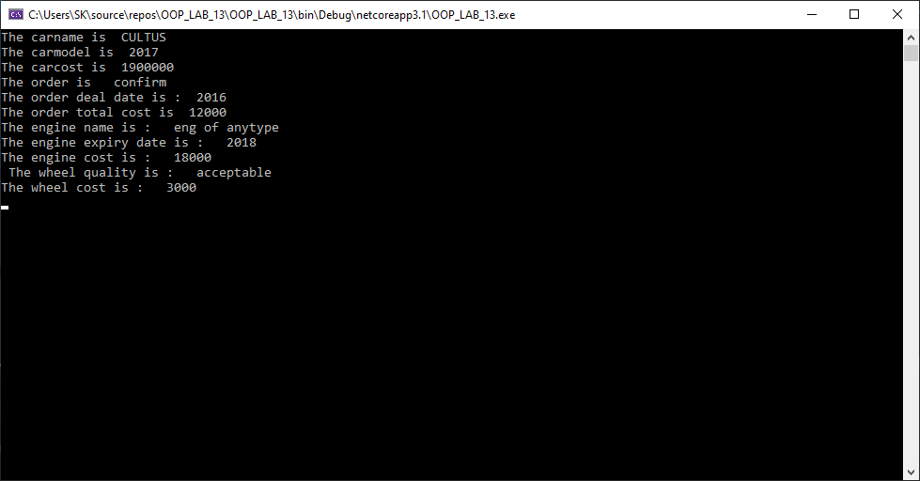

Q2) CODING:

using System;

namespace OOPlab13

{

class programm

{

static void Main(string[] args)

{

human HM = new human("MUAHMMAD AREEB", 20, "TWO LEGS", "TWO HANDS");

HM.printinfo();

Console.ReadLine();

}

}

class human

{

string humaanname;

int humanagge;

leg legg;

hand handd;

public human(string hNAME, int hAGE, string hLEG, string hHAND)

{

legg = new leg();

handd = new hand();

humaanname = hNAME;

humanagge = hAGE;

legg.humanleg = hLEG;

handd.humanhand = hHAND;

}

public void printinfo()

{

Console.WriteLine("human name is" + " " + humaanname);

Console.WriteLine("human age is" + " " + humanagge);

Console.WriteLine("human has" + " " + legg.humanleg);

Console.WriteLine("human has" + " " + handd.humanhand);

}

}

class leg

{

public string humanleg;

}

class hand

{

public string humanhand;

}

}

OUTPUT:

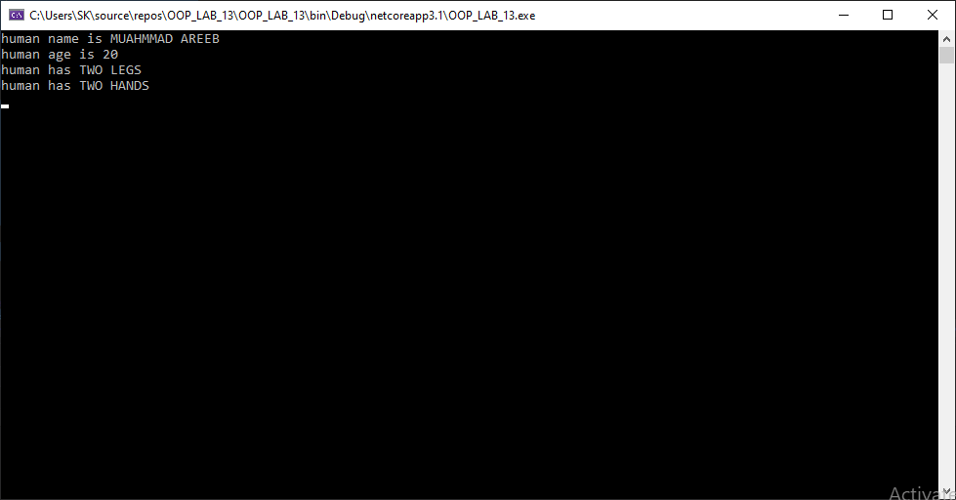

Q3) CODING:

using System;

namespace OOPlab13

{

class programm

{

static void Main(string[] args)

{

hrmanager OBJ1 = new hrmanager("MUHAMMAD AREEB");

contract OBJ2 = new contract("6 JULY 2021", "GENERAL EMPLOYMENT CONTRACT"); OBJ1.manages(OBJ2);

Console.ReadLine();

}

}

class contract

{

public string startdaate;

public string contraccttype;

public contract(string SDATE, string CTYPE)

{

startdaate = SDATE;

contraccttype = CTYPE;

}

}

class hrmanager

{

string name;

public hrmanager(string NAMEE)

{

name = NAMEE;

}

public void manages(contract CONTRACTS)

{

Console.WriteLine(" Manager name is " + " " + name);

Console.WriteLine("Contrat starts on " + " " + CONTRACTS.startdaate);

Console.WriteLine("Contract type is " + " " + CONTRACTS.contraccttype);

}

}

}

OUTPUT:

